John Madias

CS 639

**Part 3:**

GitHub is an application that allows for the collaboration of projects, which helps users manage software projects. To be more exact it is a code hosting site for version control using Git. GitHub was officially launched in 2008 (first commit in 2007) by Chris Wanstrath, PJ Hyett, Tom Preston-Werner, and Scott Chacon. Github was created for the need to help teams keep code in one centralized place, where projects can be managed, worked on separately, in a safe environment that minimizes the introduction of bugs in code. Other platforms such as Bitbucket, GitLab, CodePlex, Launchpad and SourceForge exist that are similar to GitHub. These types of platforms would be used when there is a need to collaborate on a project or multiple projects, to help team members keep track of changes, minimize sloppy code, allow for review of changes, allow individuals to work on projects at the same time and keep the work in a safe setting.

**Part 4: (Git tutorial work)**

**Introduction Sequence**

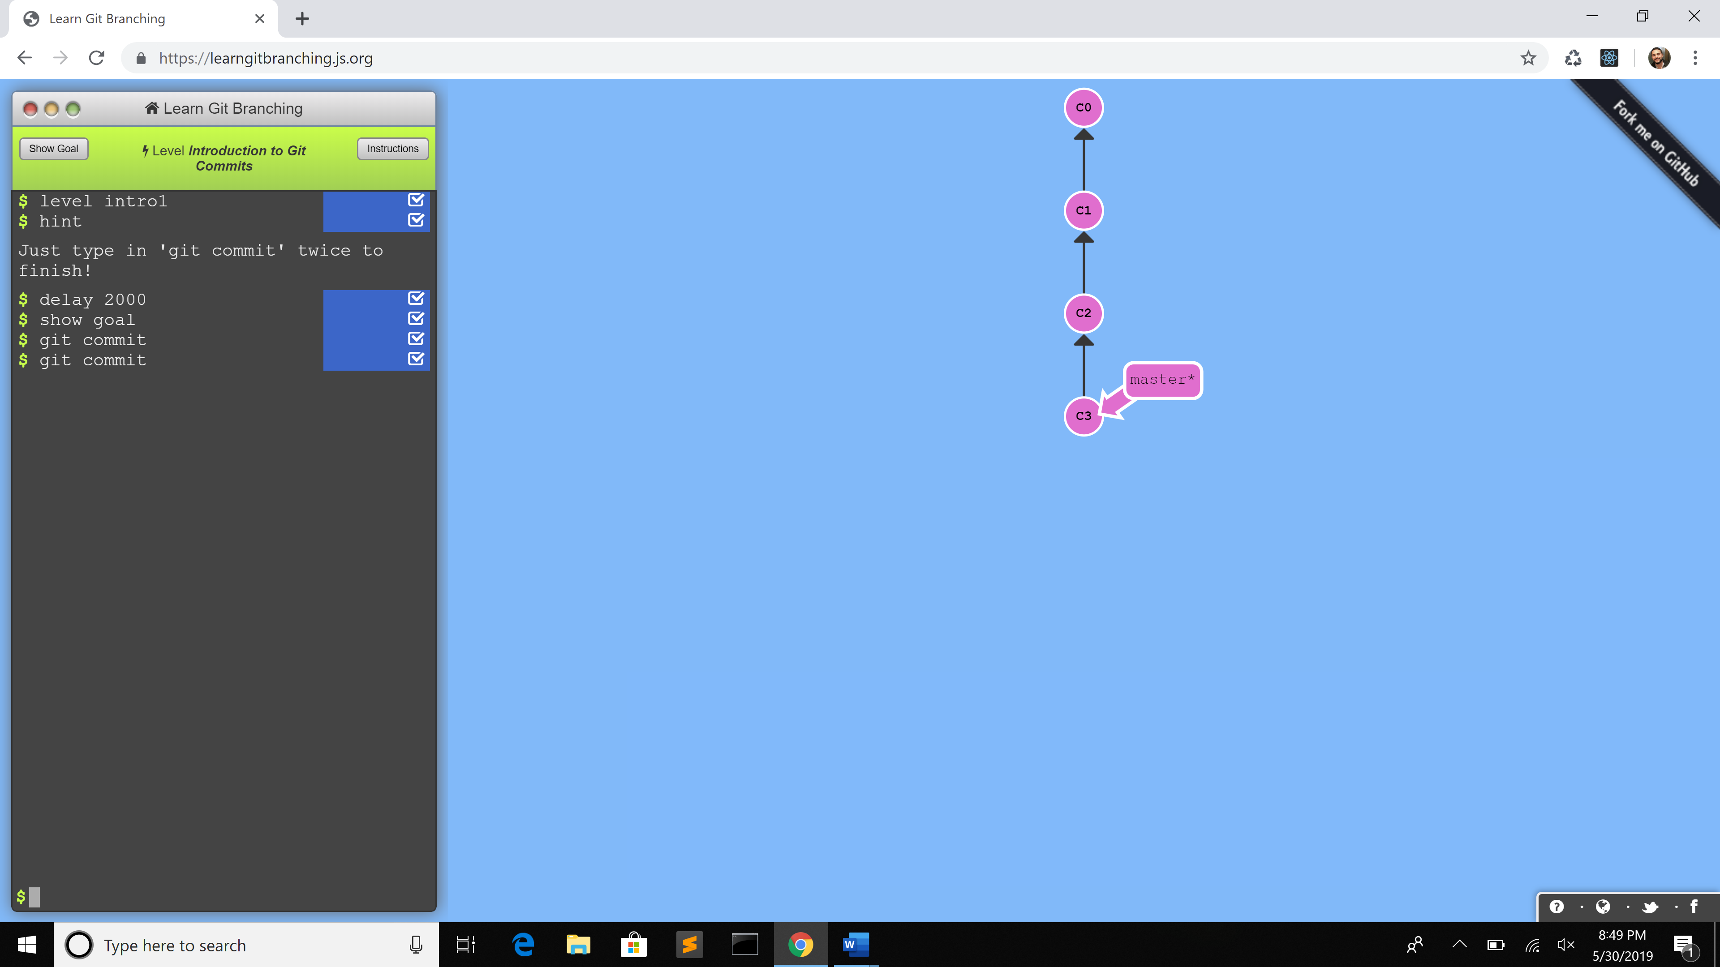

1. Git commit - made changes to the repository and saved them as a commit.

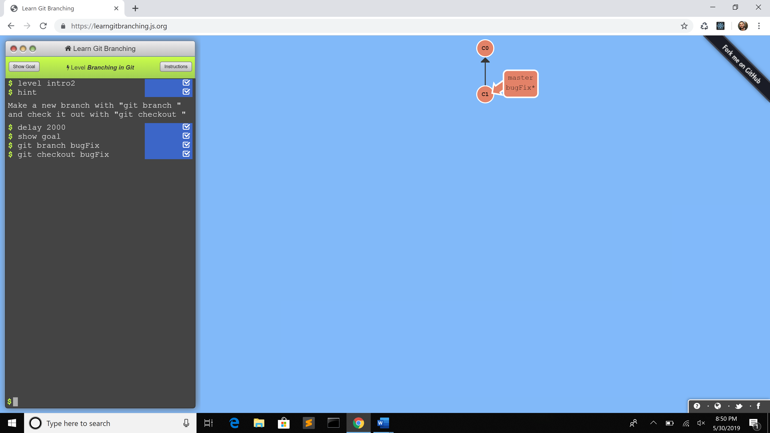

1. Commands:
   1. git branch – created new branch
   2. git checkout – to switch to that branch

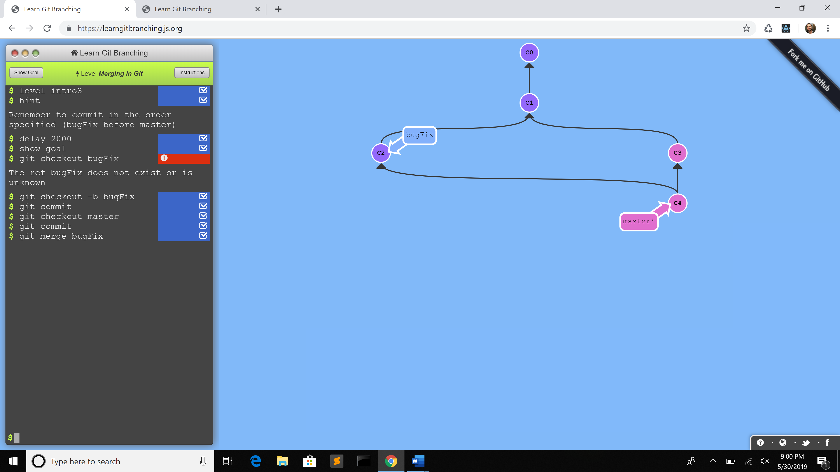

1. Commands:
   1. git checkout
   2. git commit
   3. git merge – merges the branch bugFix into master with git merge

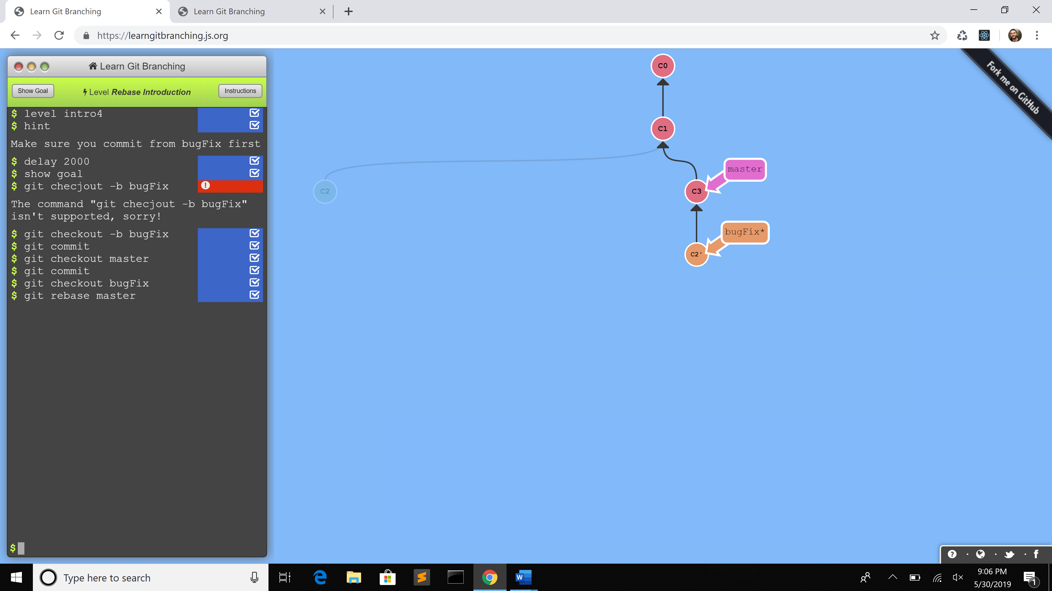

1. Commands:
   1. git checkout
   2. git commit
   3. git rebase – another way of combining work between branches (Check out bugFix again and rebase onto master)

**Ramping Up**

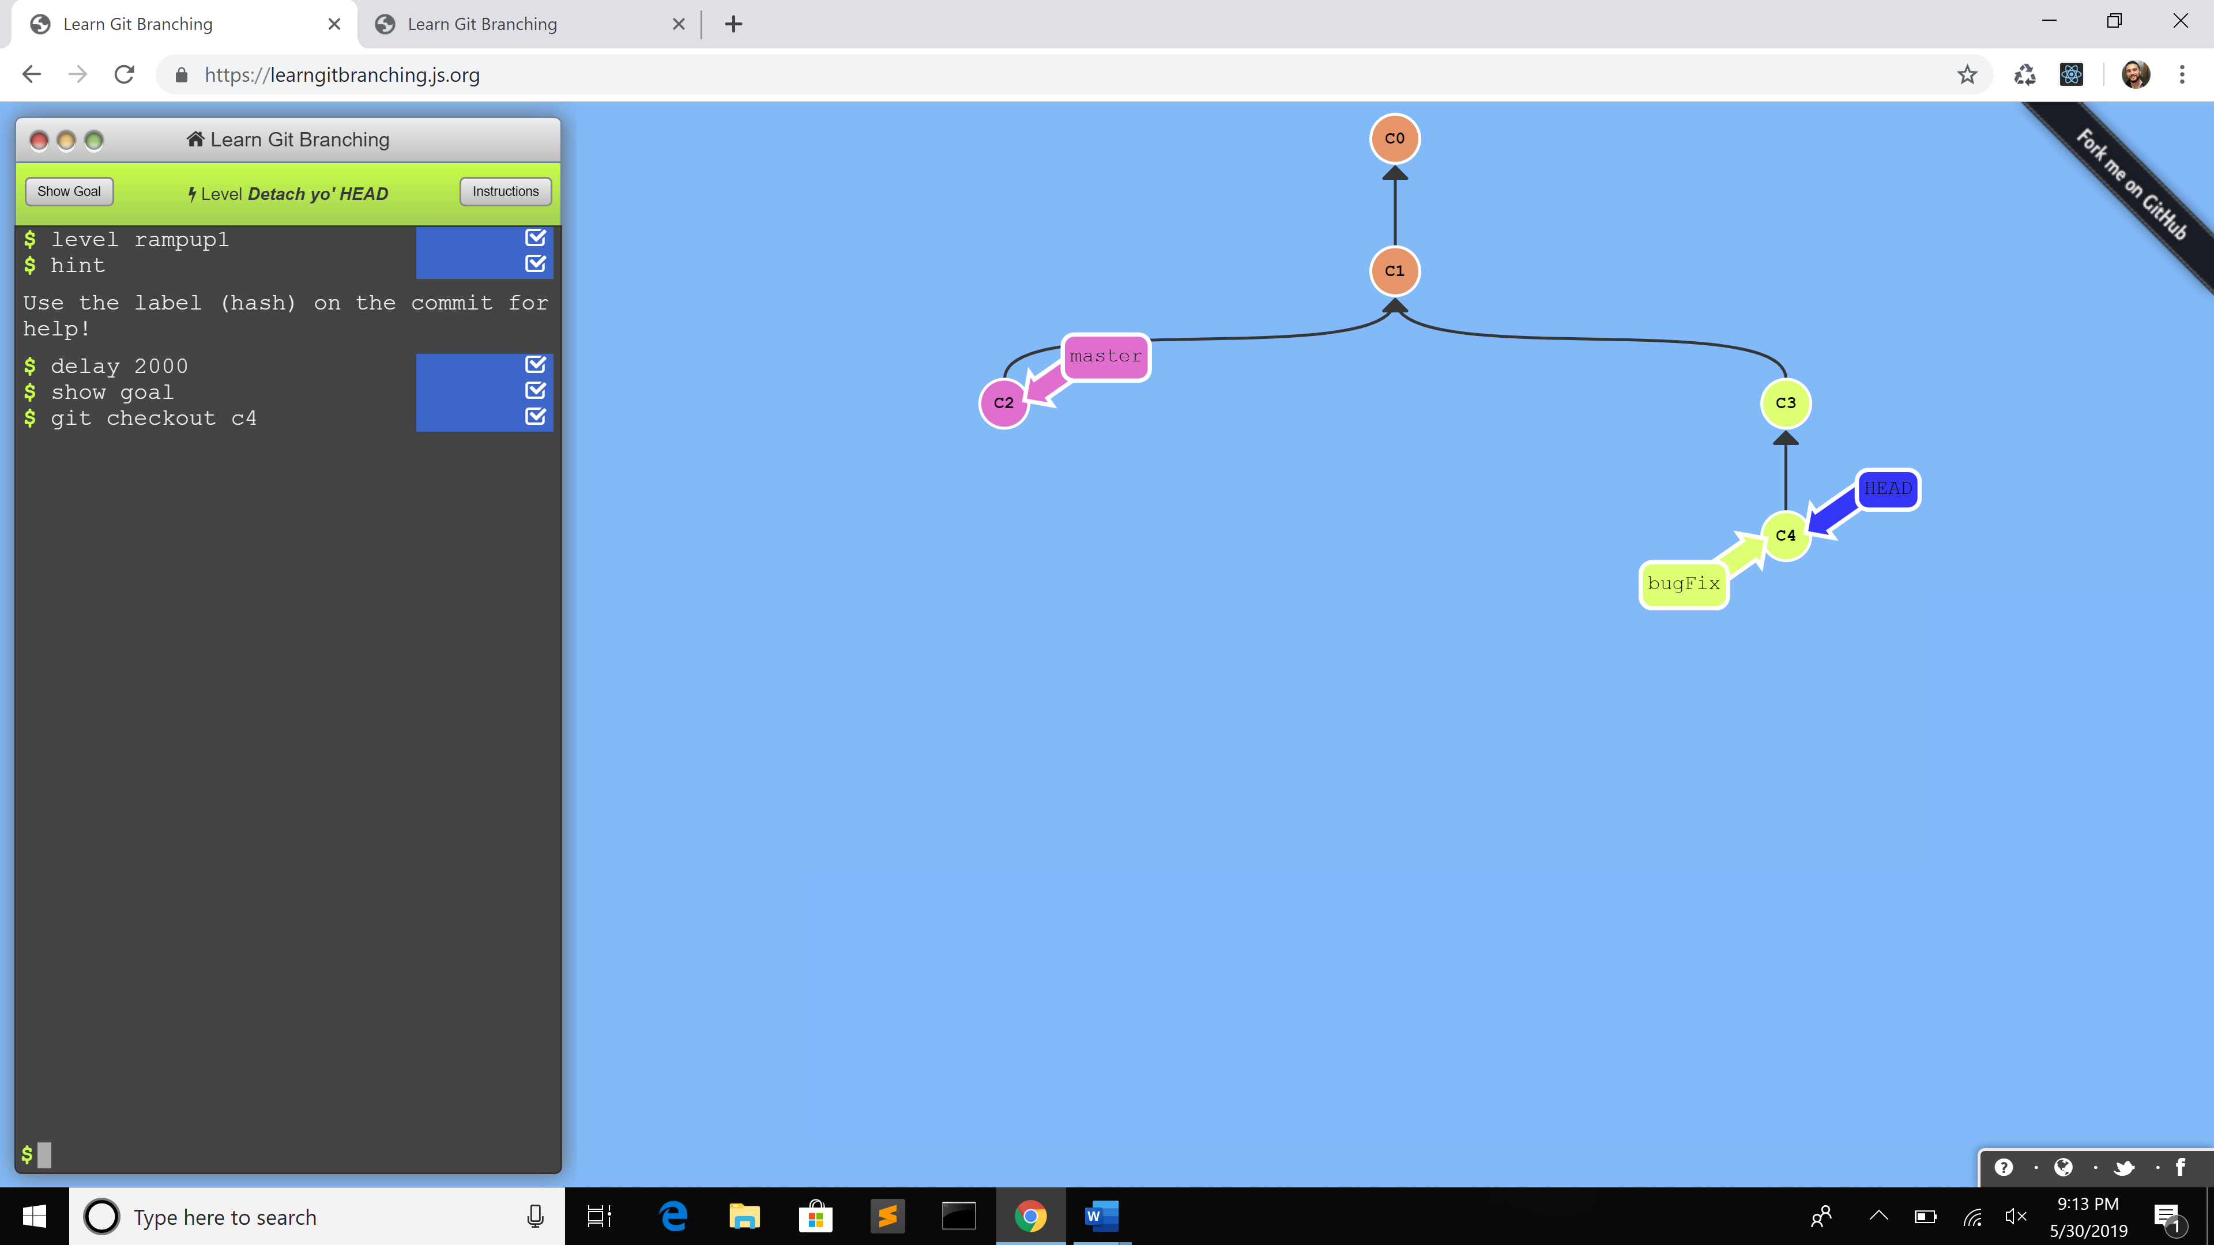

1. Commands:
   1. git checkout C4 - Detach HEAD and attaching it to a commit c4 instead of a branch.

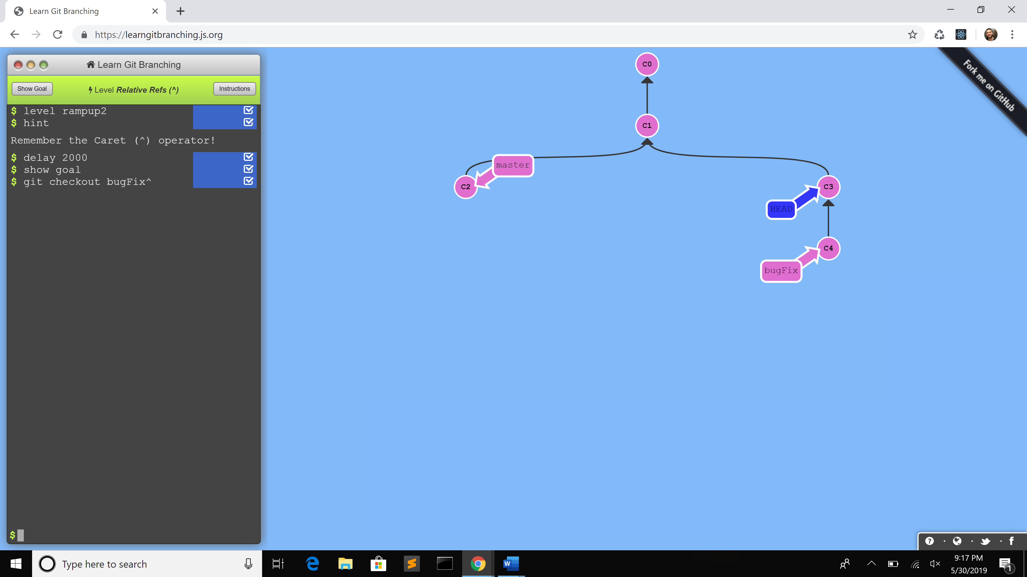

1. Commands:
   1. git checkout bugfix^ - Moving upwards one commit at with ^

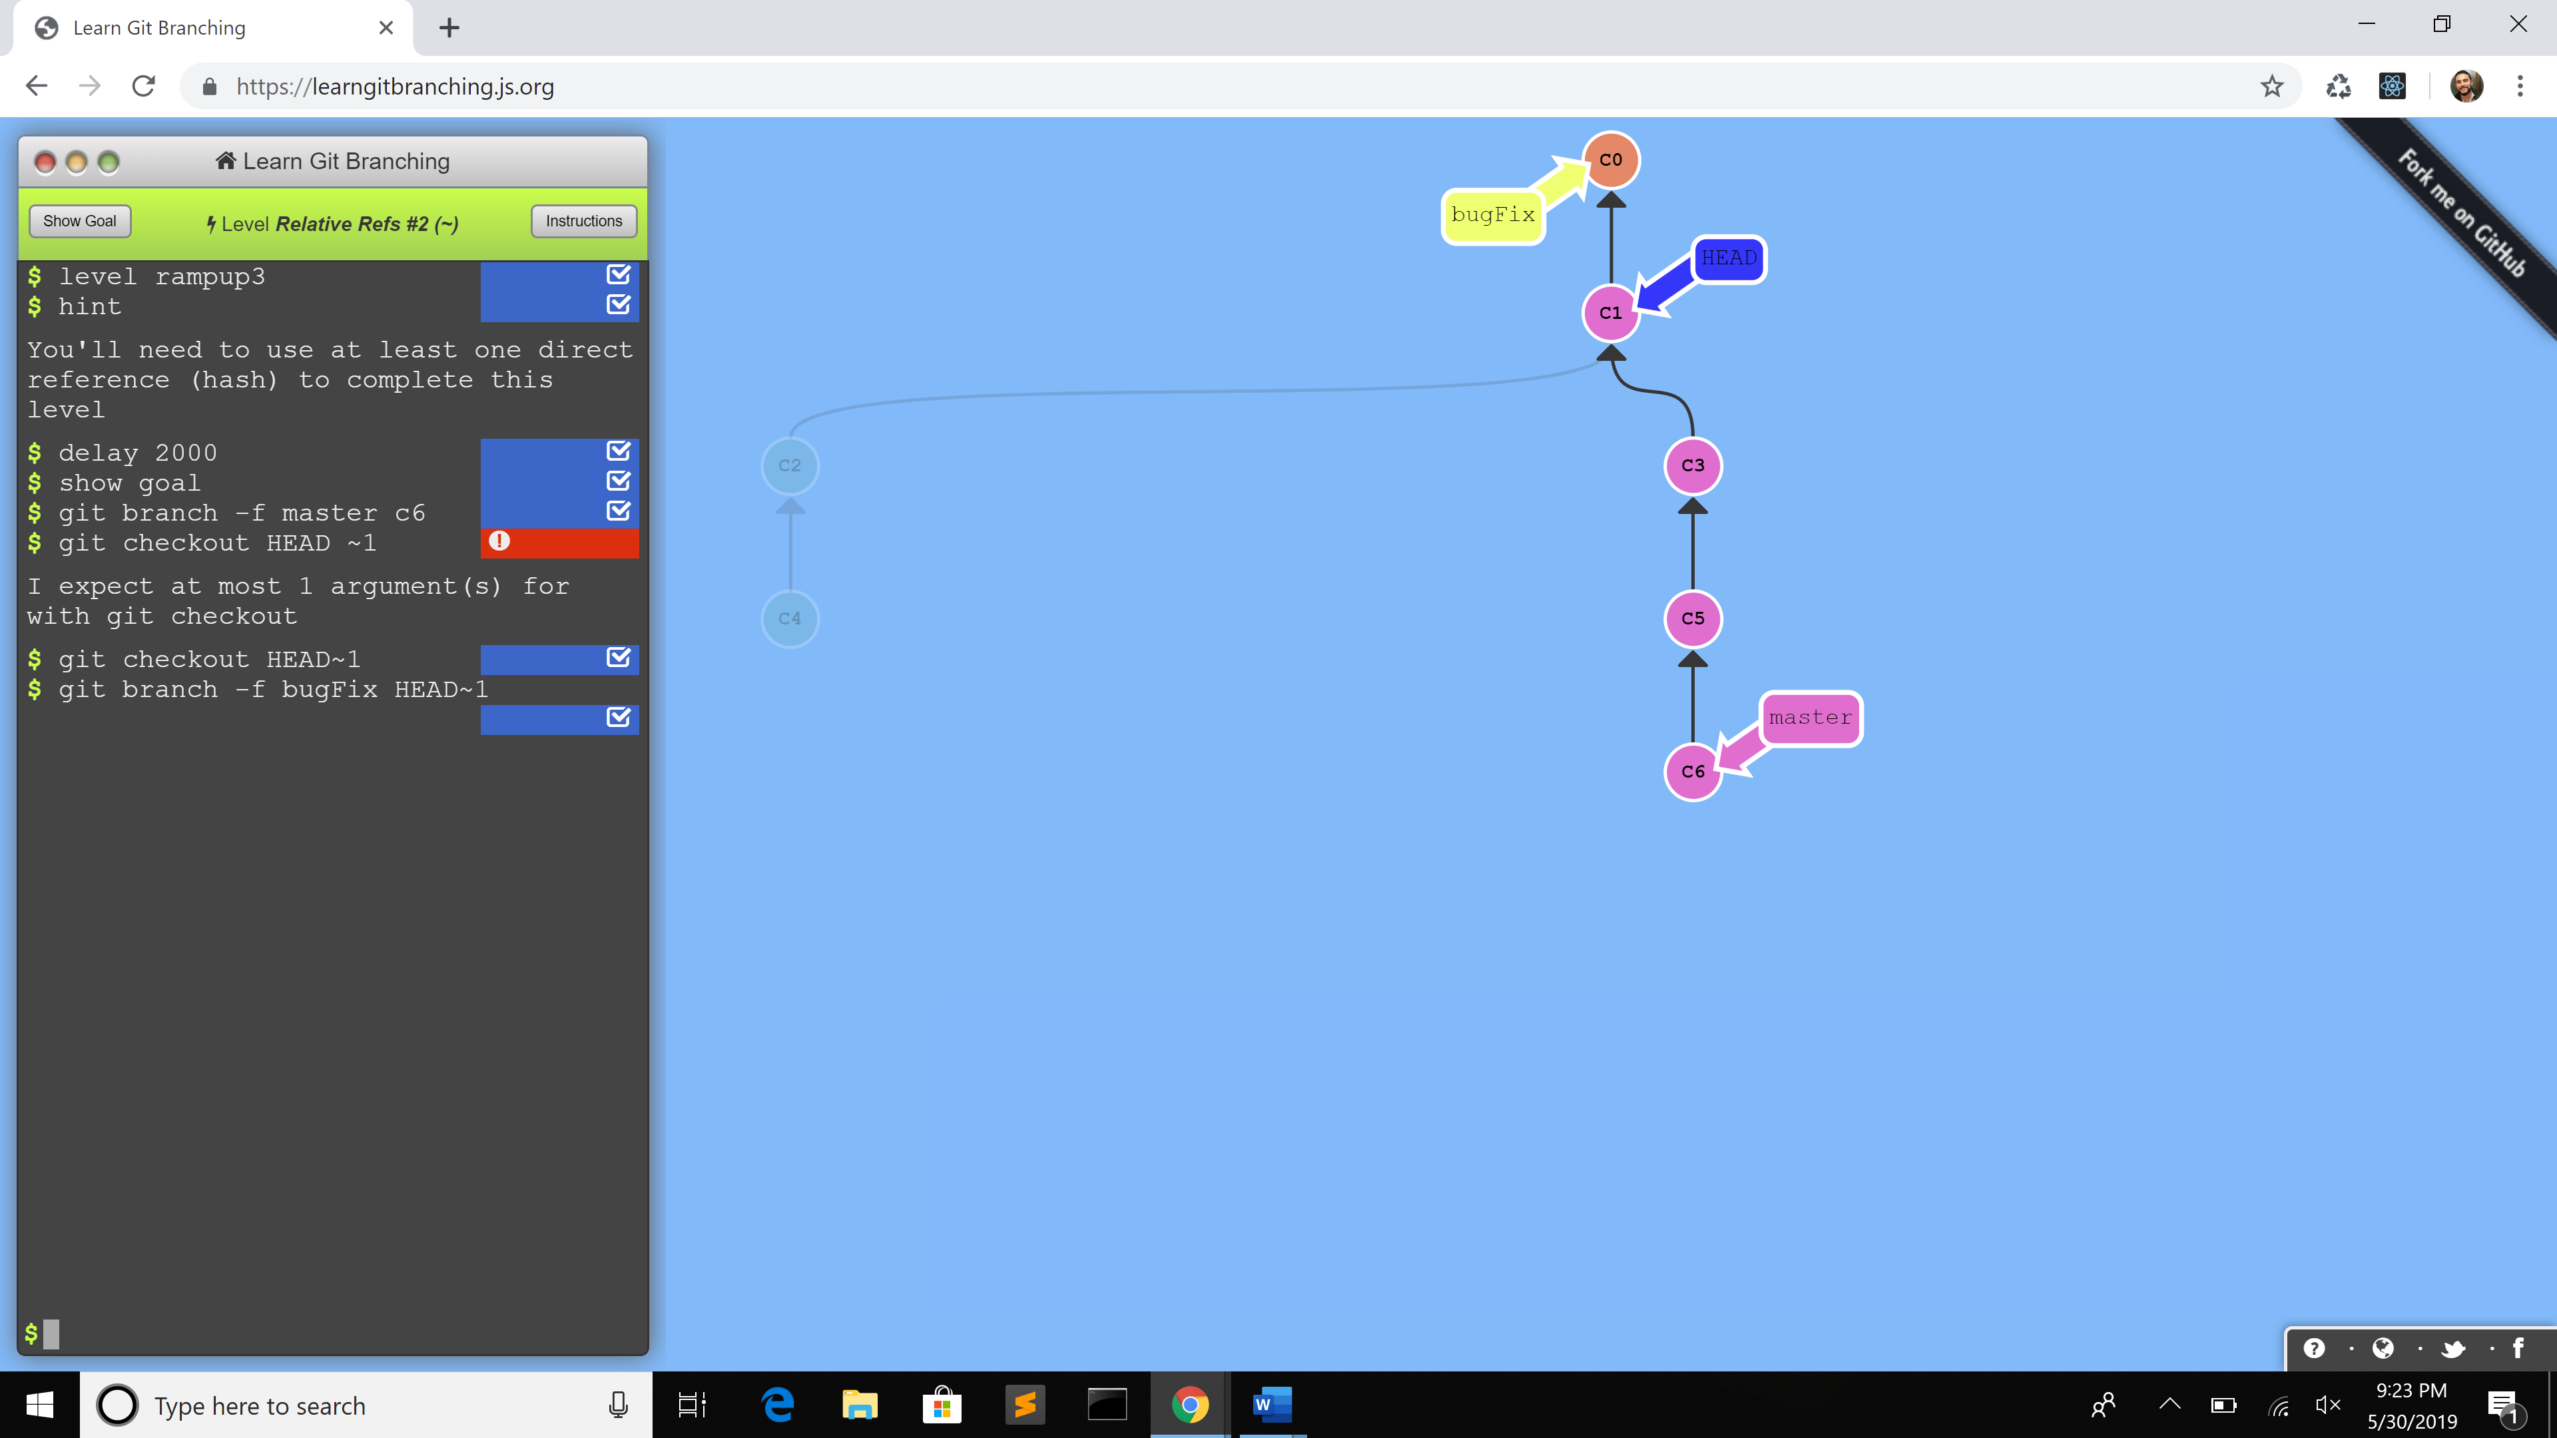

1. Commands:
   1. git branch -f master c6 – (f) to force reassign a branch to a commit
   2. git checkout HEAD~1 – (~) operator takes in a trailing number that specifies the number of to ascend)
   3. git branch -f bugfix HEAD~1

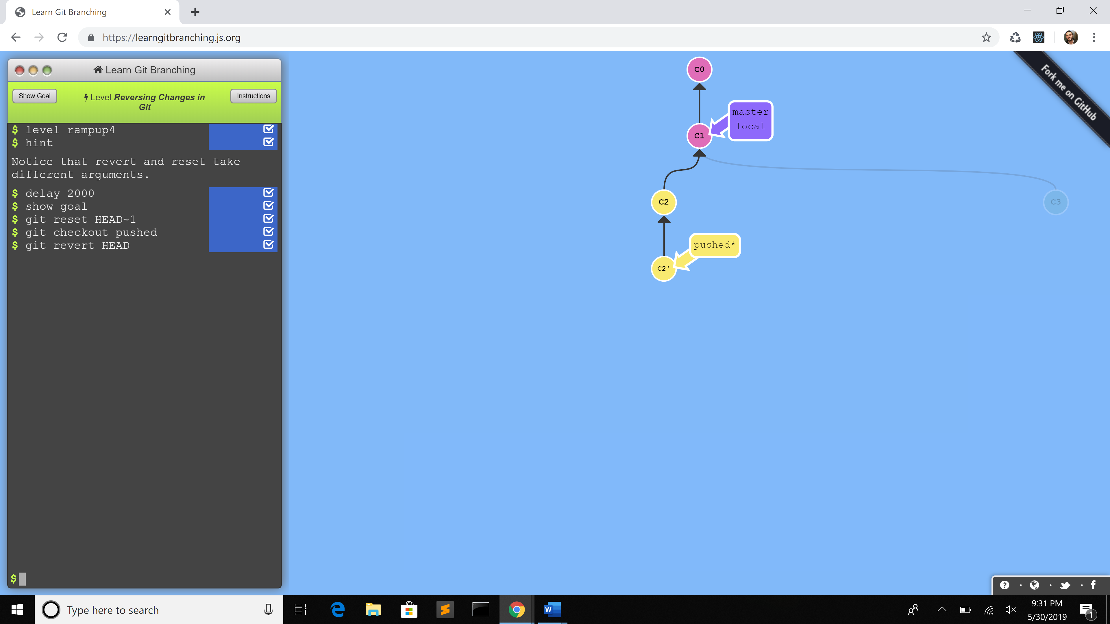

1. Commands:
   1. git reset HEAD~1 - move branch backwards as if commit had never been made
   2. git checkout pushed
   3. git revert HEAD - reverse changes and share reversed changes

**Moving Work Around**

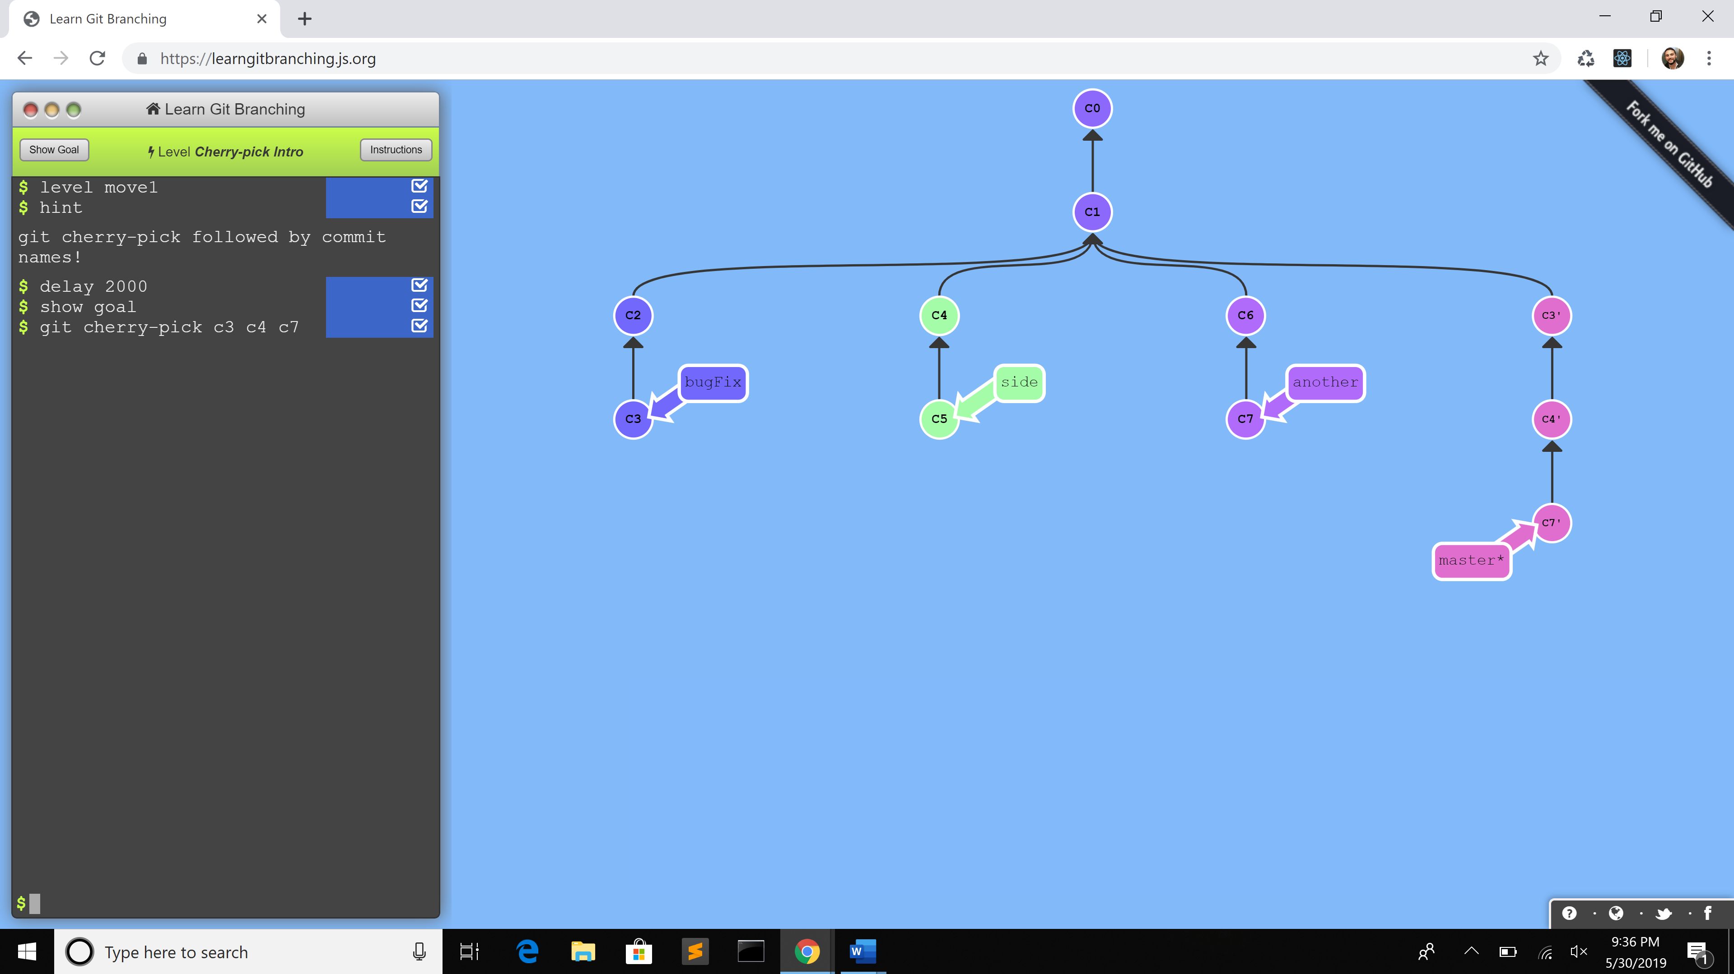

1. Commands:
   1. git cherry-pick C3 C4 C7 – to copy a series of commits below your current location

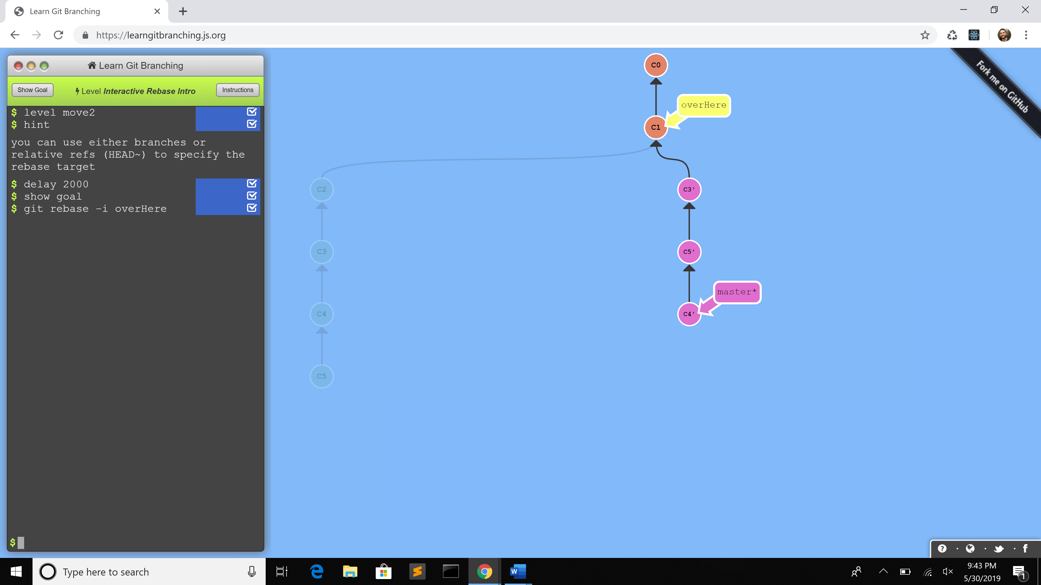

1. Commands:
   1. git rebase -i overHere - interactive rebase window will appear, reorder some commits around

**A Mixed Bag**

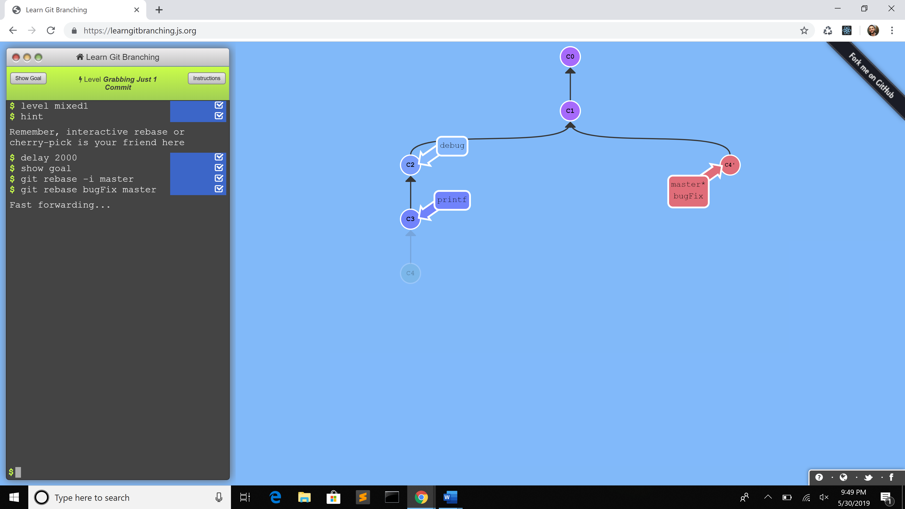

1. Commands:
   1. git rebase -i master - interactive rebase window will appear, reorder commits, omit all but c4
   2. git rebase bugfix master

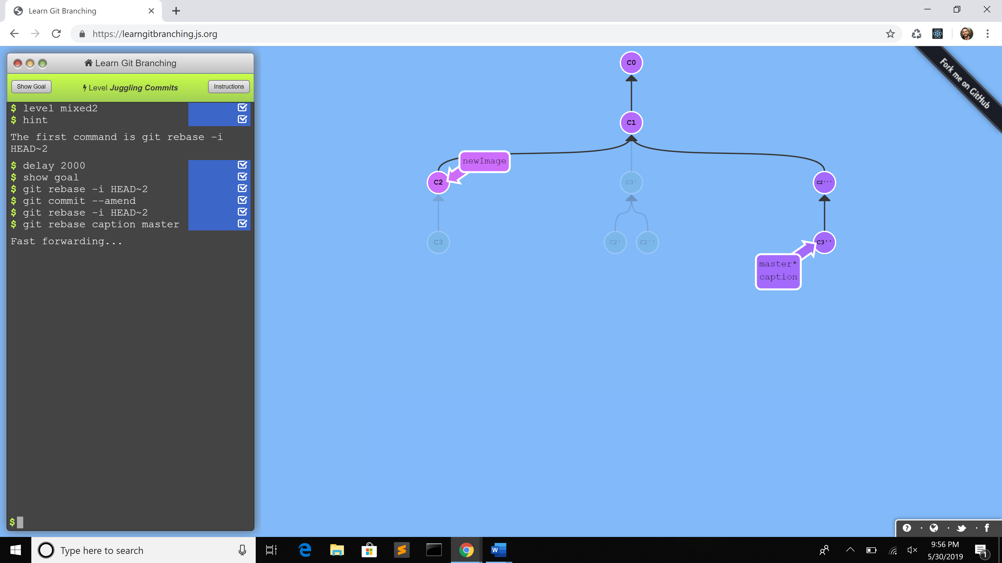

1. Commands:
   1. git rebase -i HEAD~2
   2. git commit --amend – to make slight modification
   3. git rebase -i HEAD~2
   4. git rebase caption master – caption is another set of changes that are related

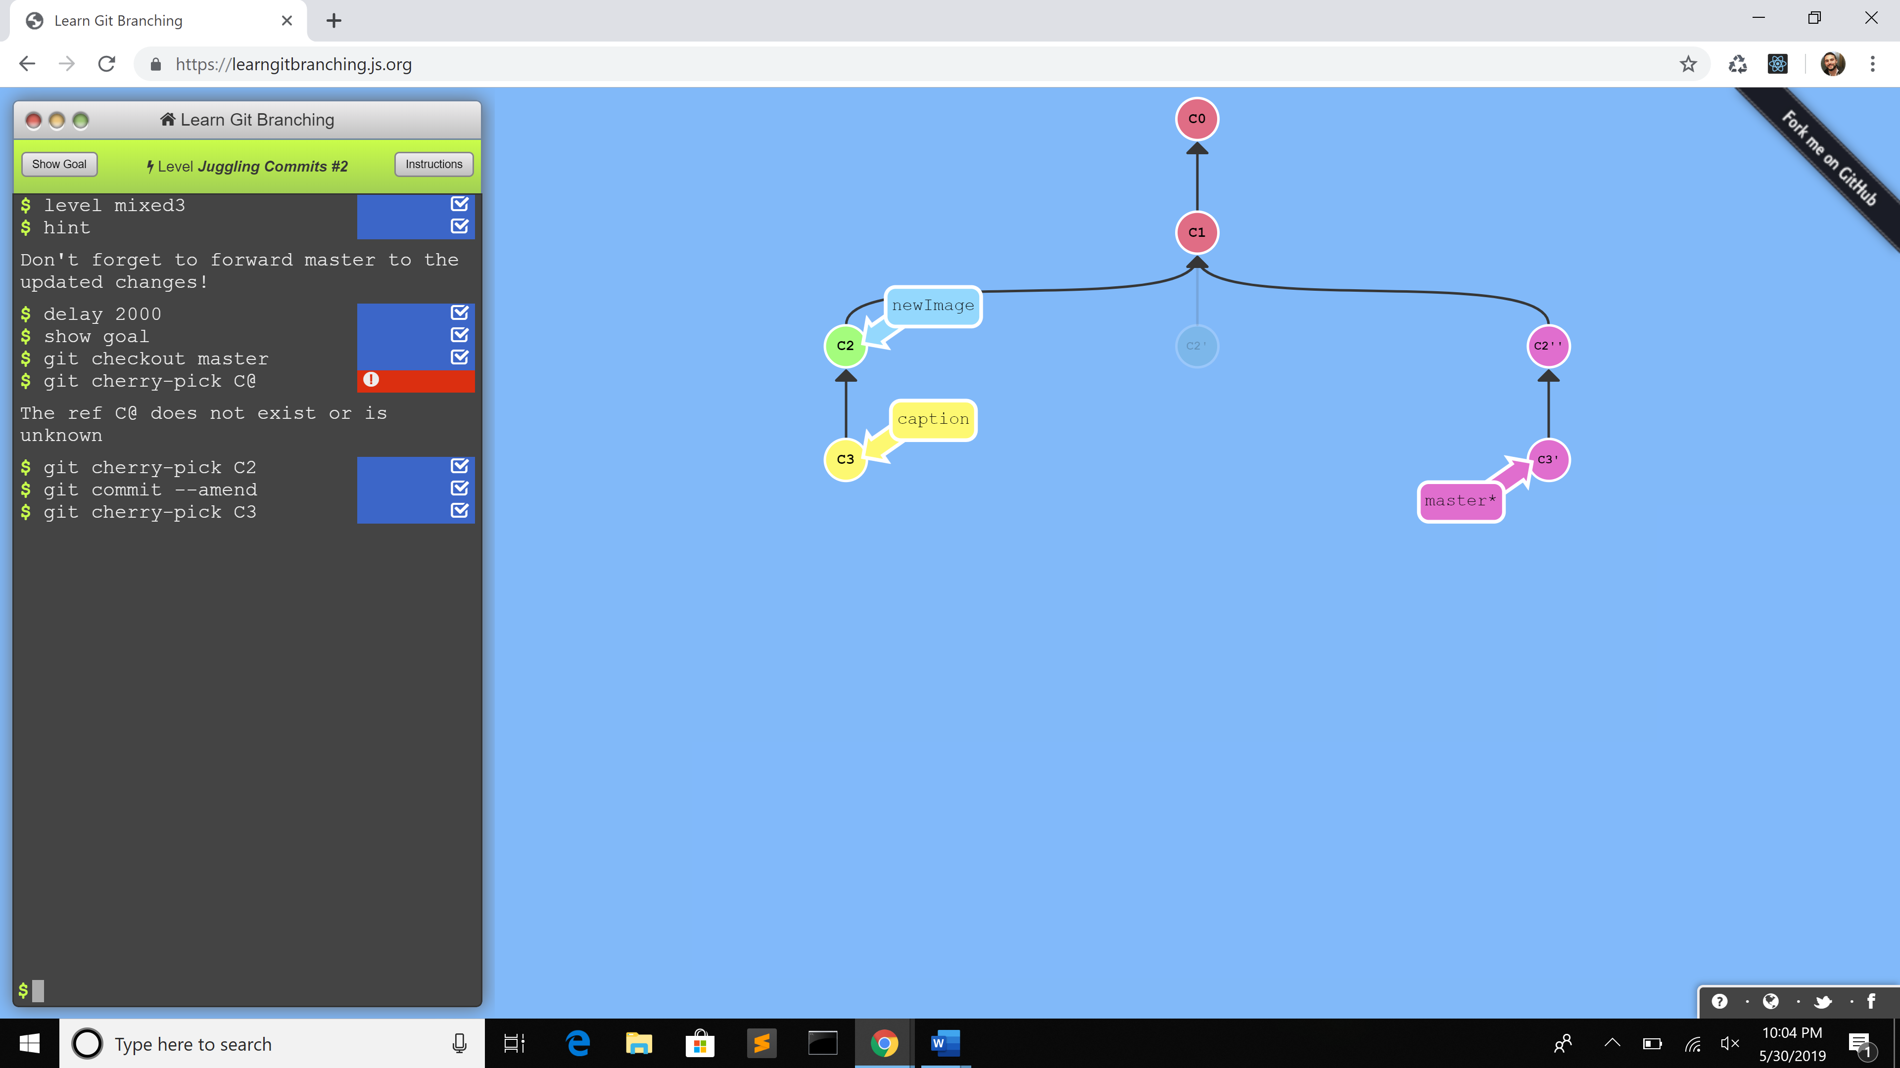

1. Commands:
   1. git checkout master
   2. git cherry-pick C2 – the cherry-pick command will plop down a commit from anywhere in the tree
   3. git commit --amend
   4. git cherry-pick C3

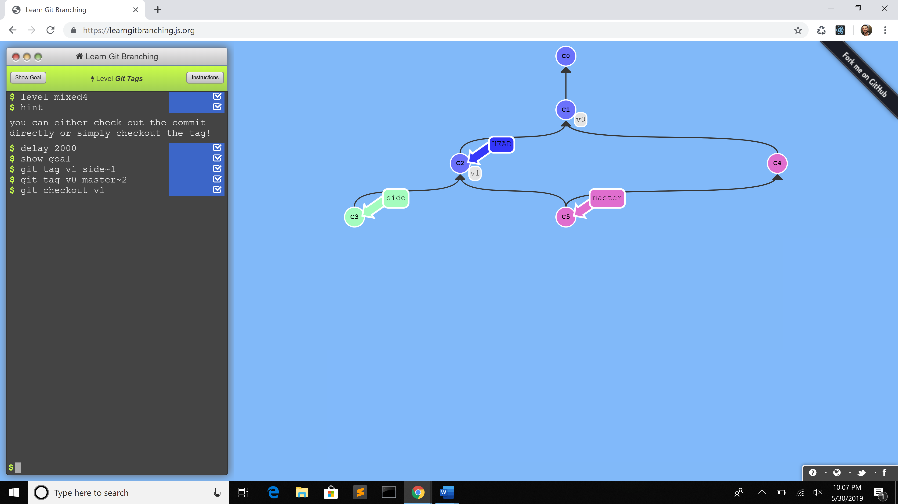

1. Commands:
   1. git tag v1 side~1 – create tag version 1 prototype
   2. git tag v0 master~2
   3. git checkout v1

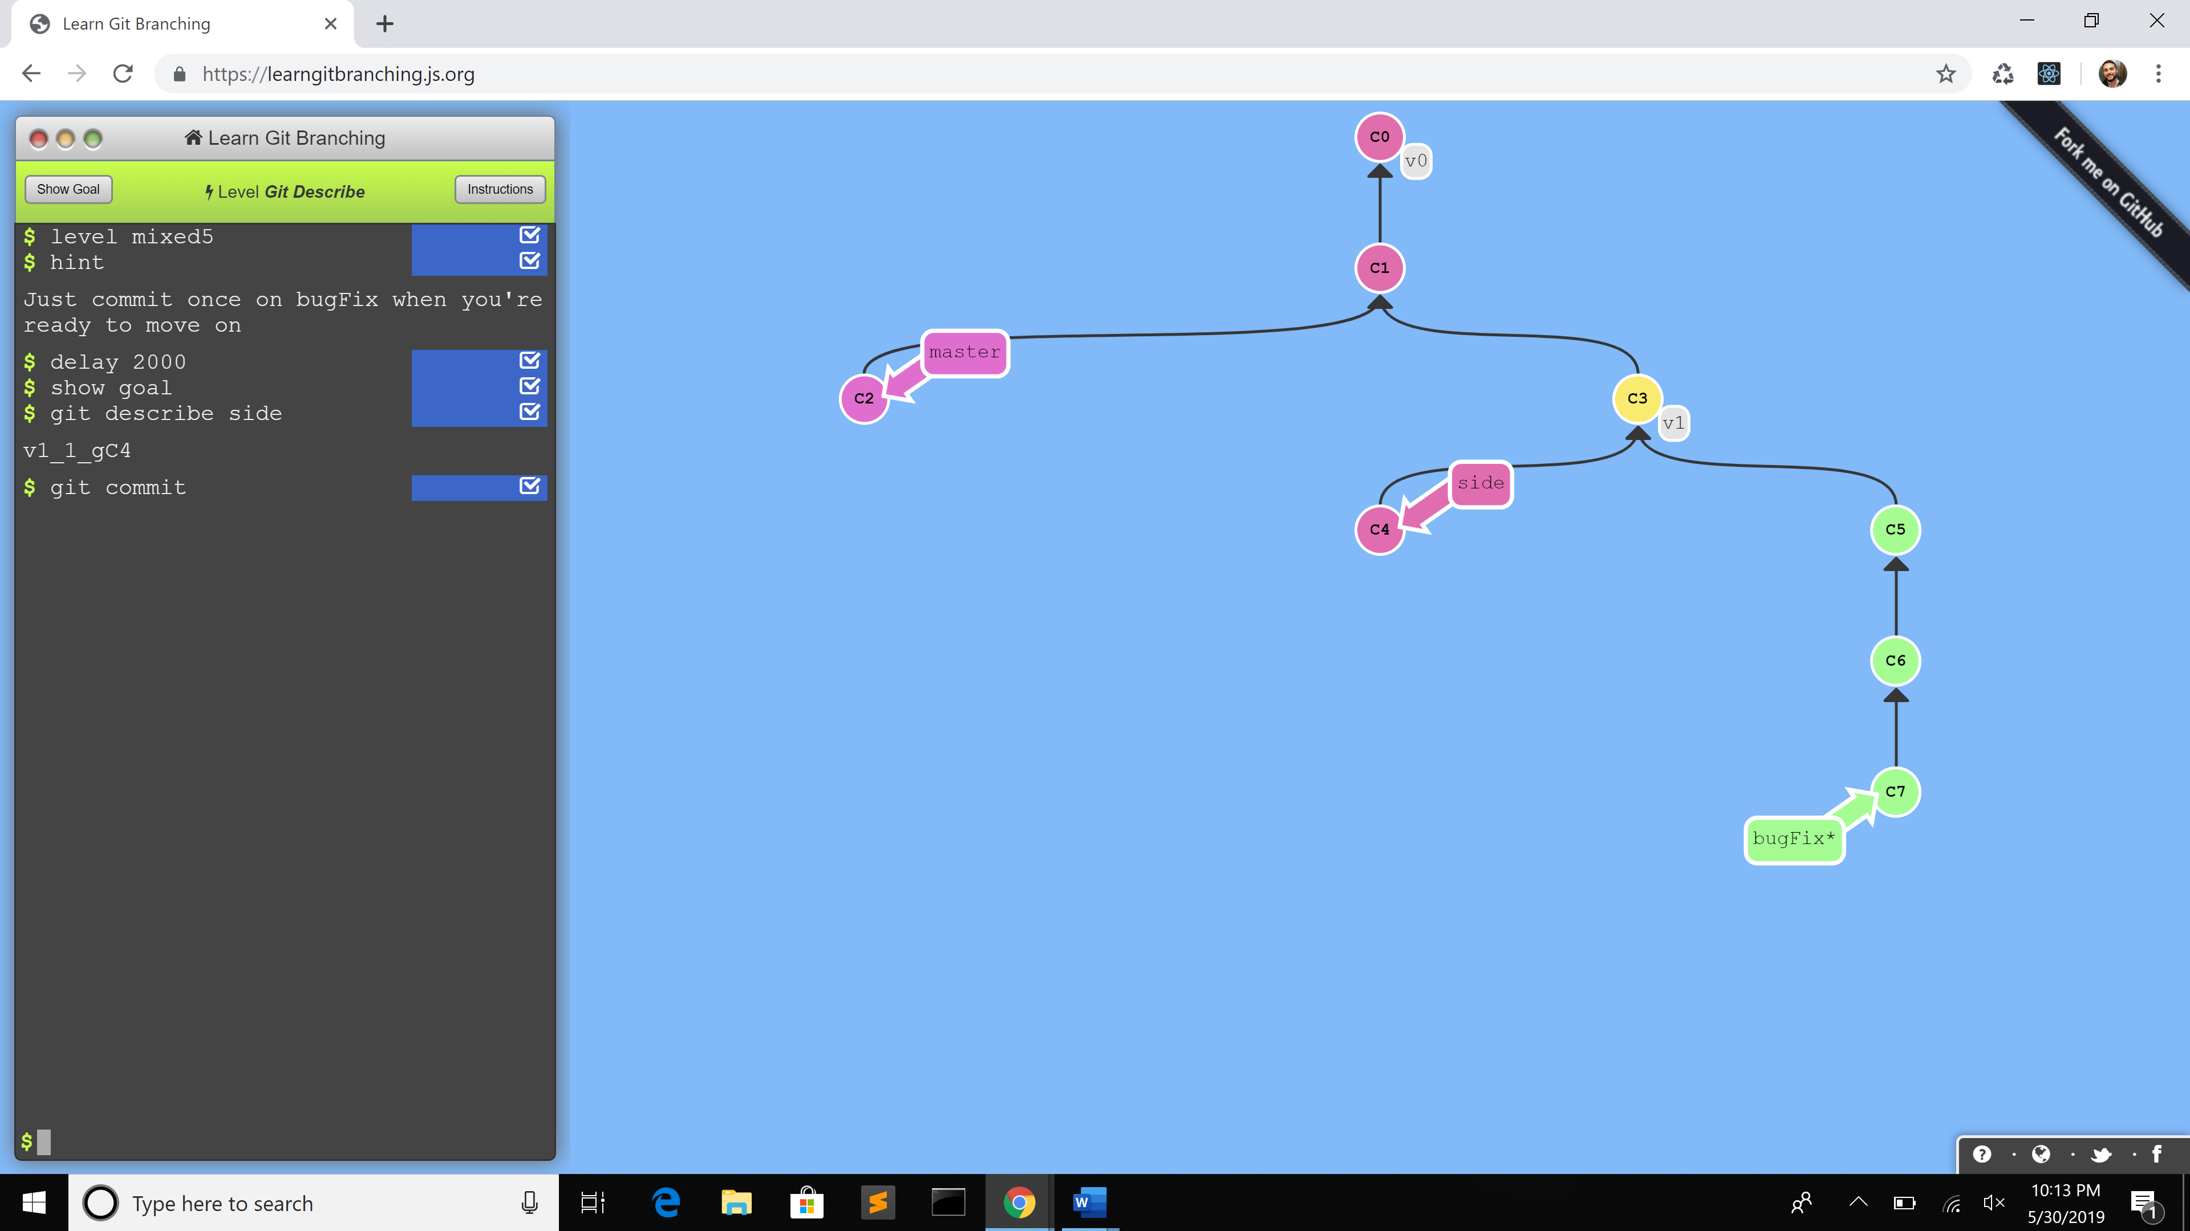

1. Commands:
   1. git describe - describe where you are relative to the closest "anchor" (aka tag)

**Advanced Topics**

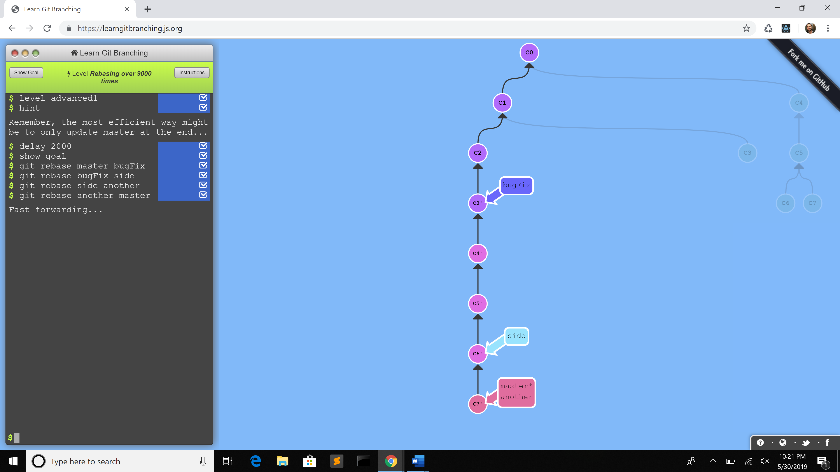

1. Commands: (these make all commits to be in sequential order)
   1. git rebase master bugfix
   2. git rebase bugfix side
   3. git rebase side another
   4. git rebase another master

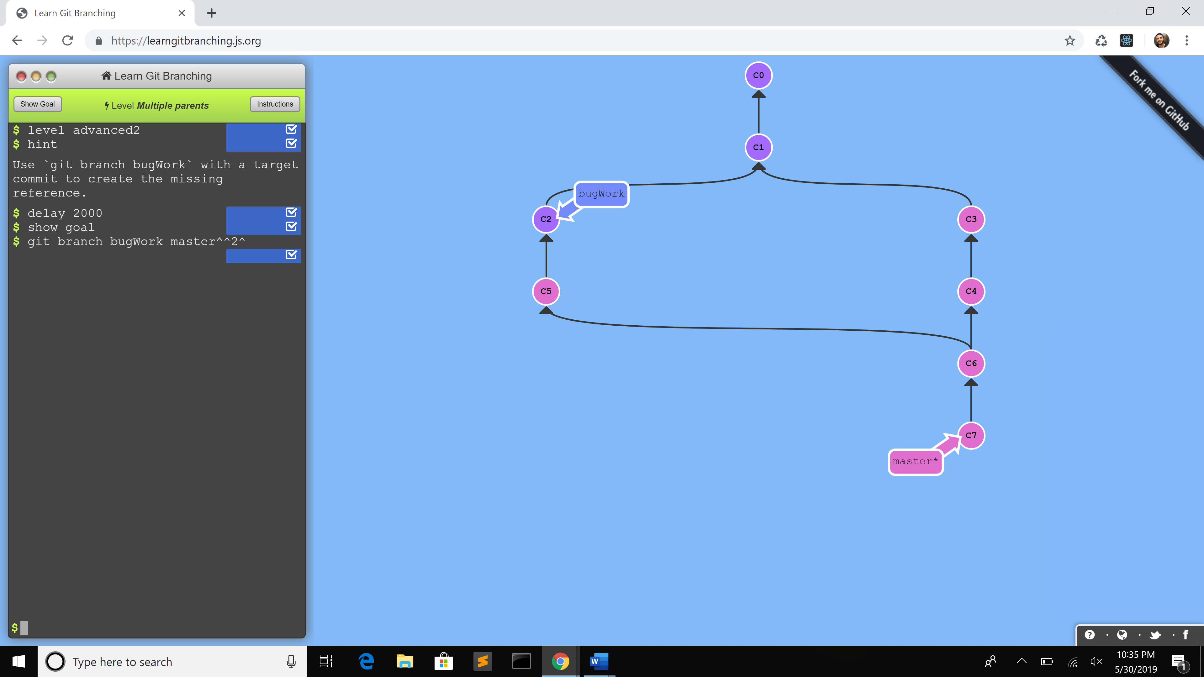

1. Commands:
   1. git branch bugWork master ^^2^ (chaining modifiers together)

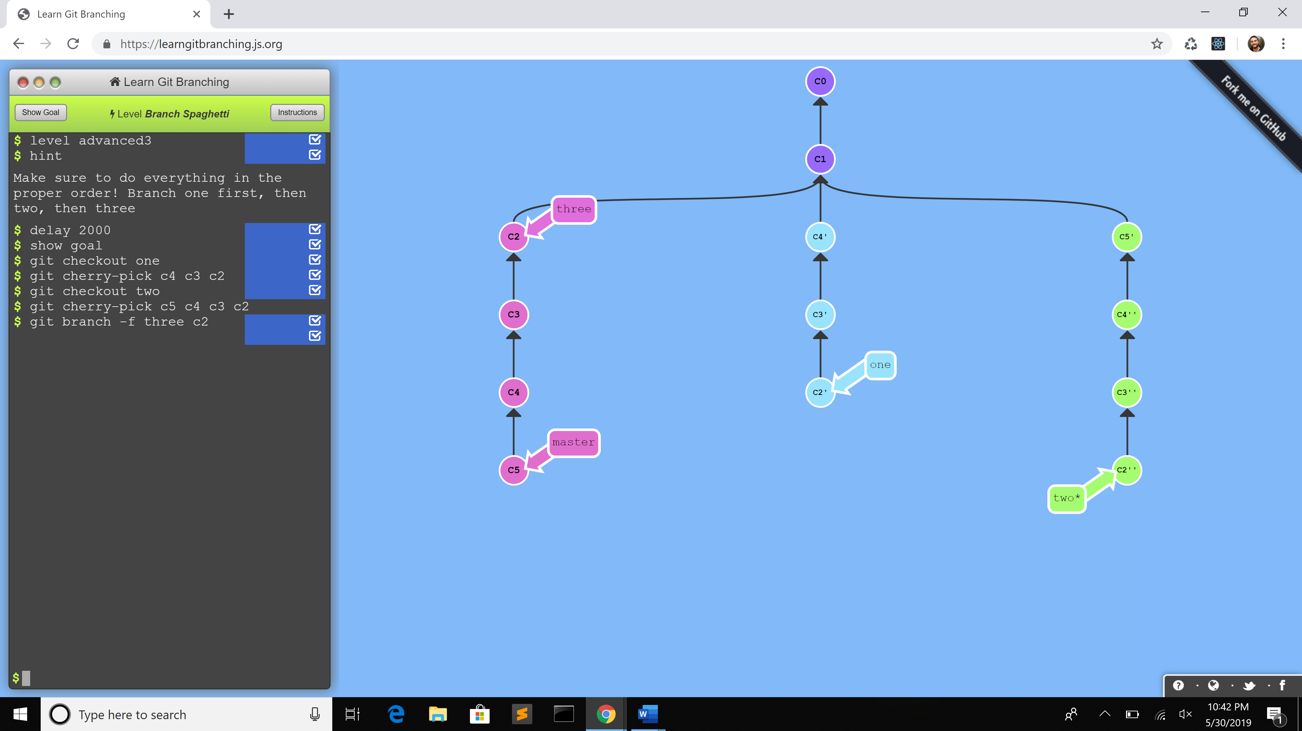

1. Commands:
   1. git checkout one
   2. git cherry-pick C4 C3 C2
   3. git checkout two
   4. git cherry-pick C5 C4 C3 C2
   5. git branch -f three C2

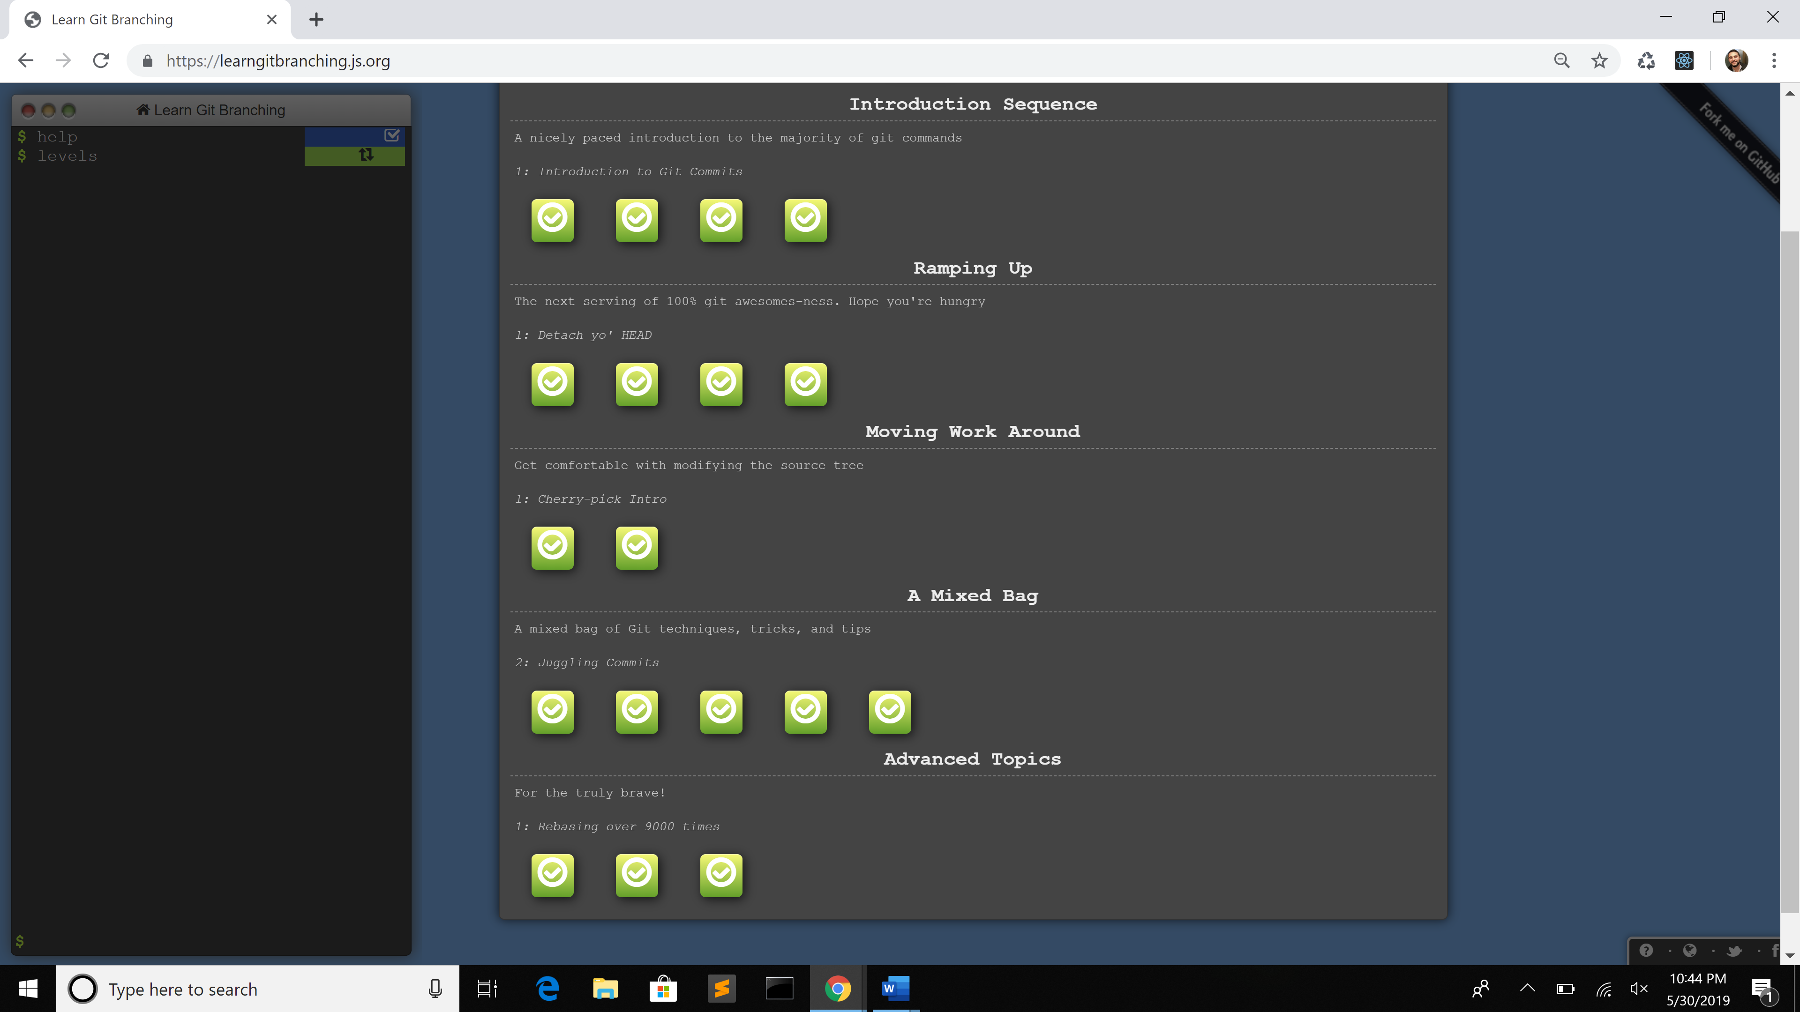

**Push & Pull -- Git Remotes!**

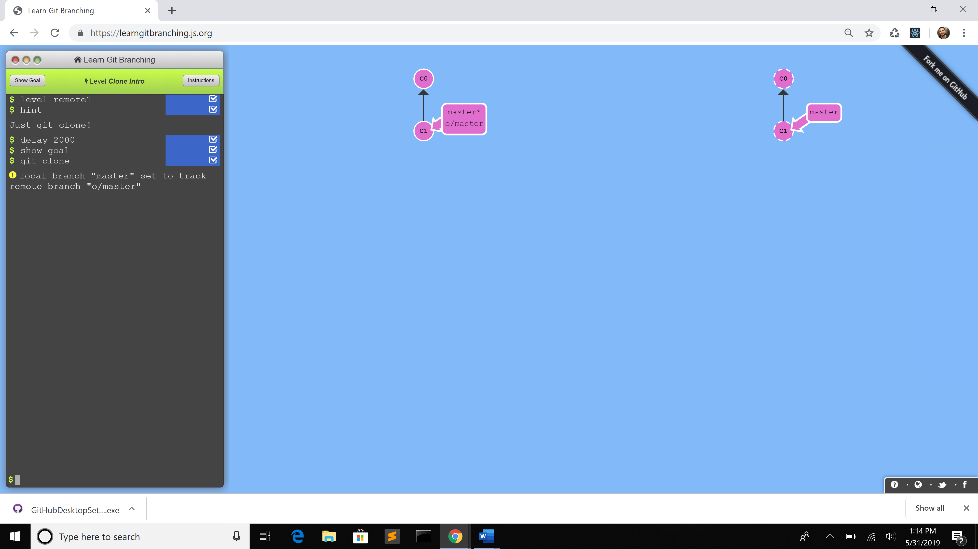

1. Commands:
   1. git clone - makes a remote repository out of your local one

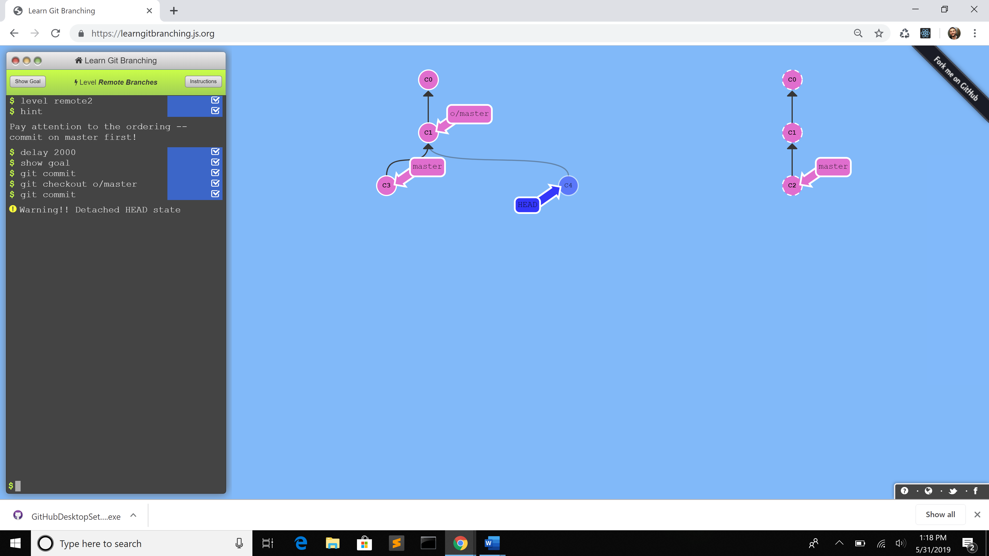

1. Commands:
   1. git commit
   2. git checkout o/master – to check out remote branch
   3. git commit

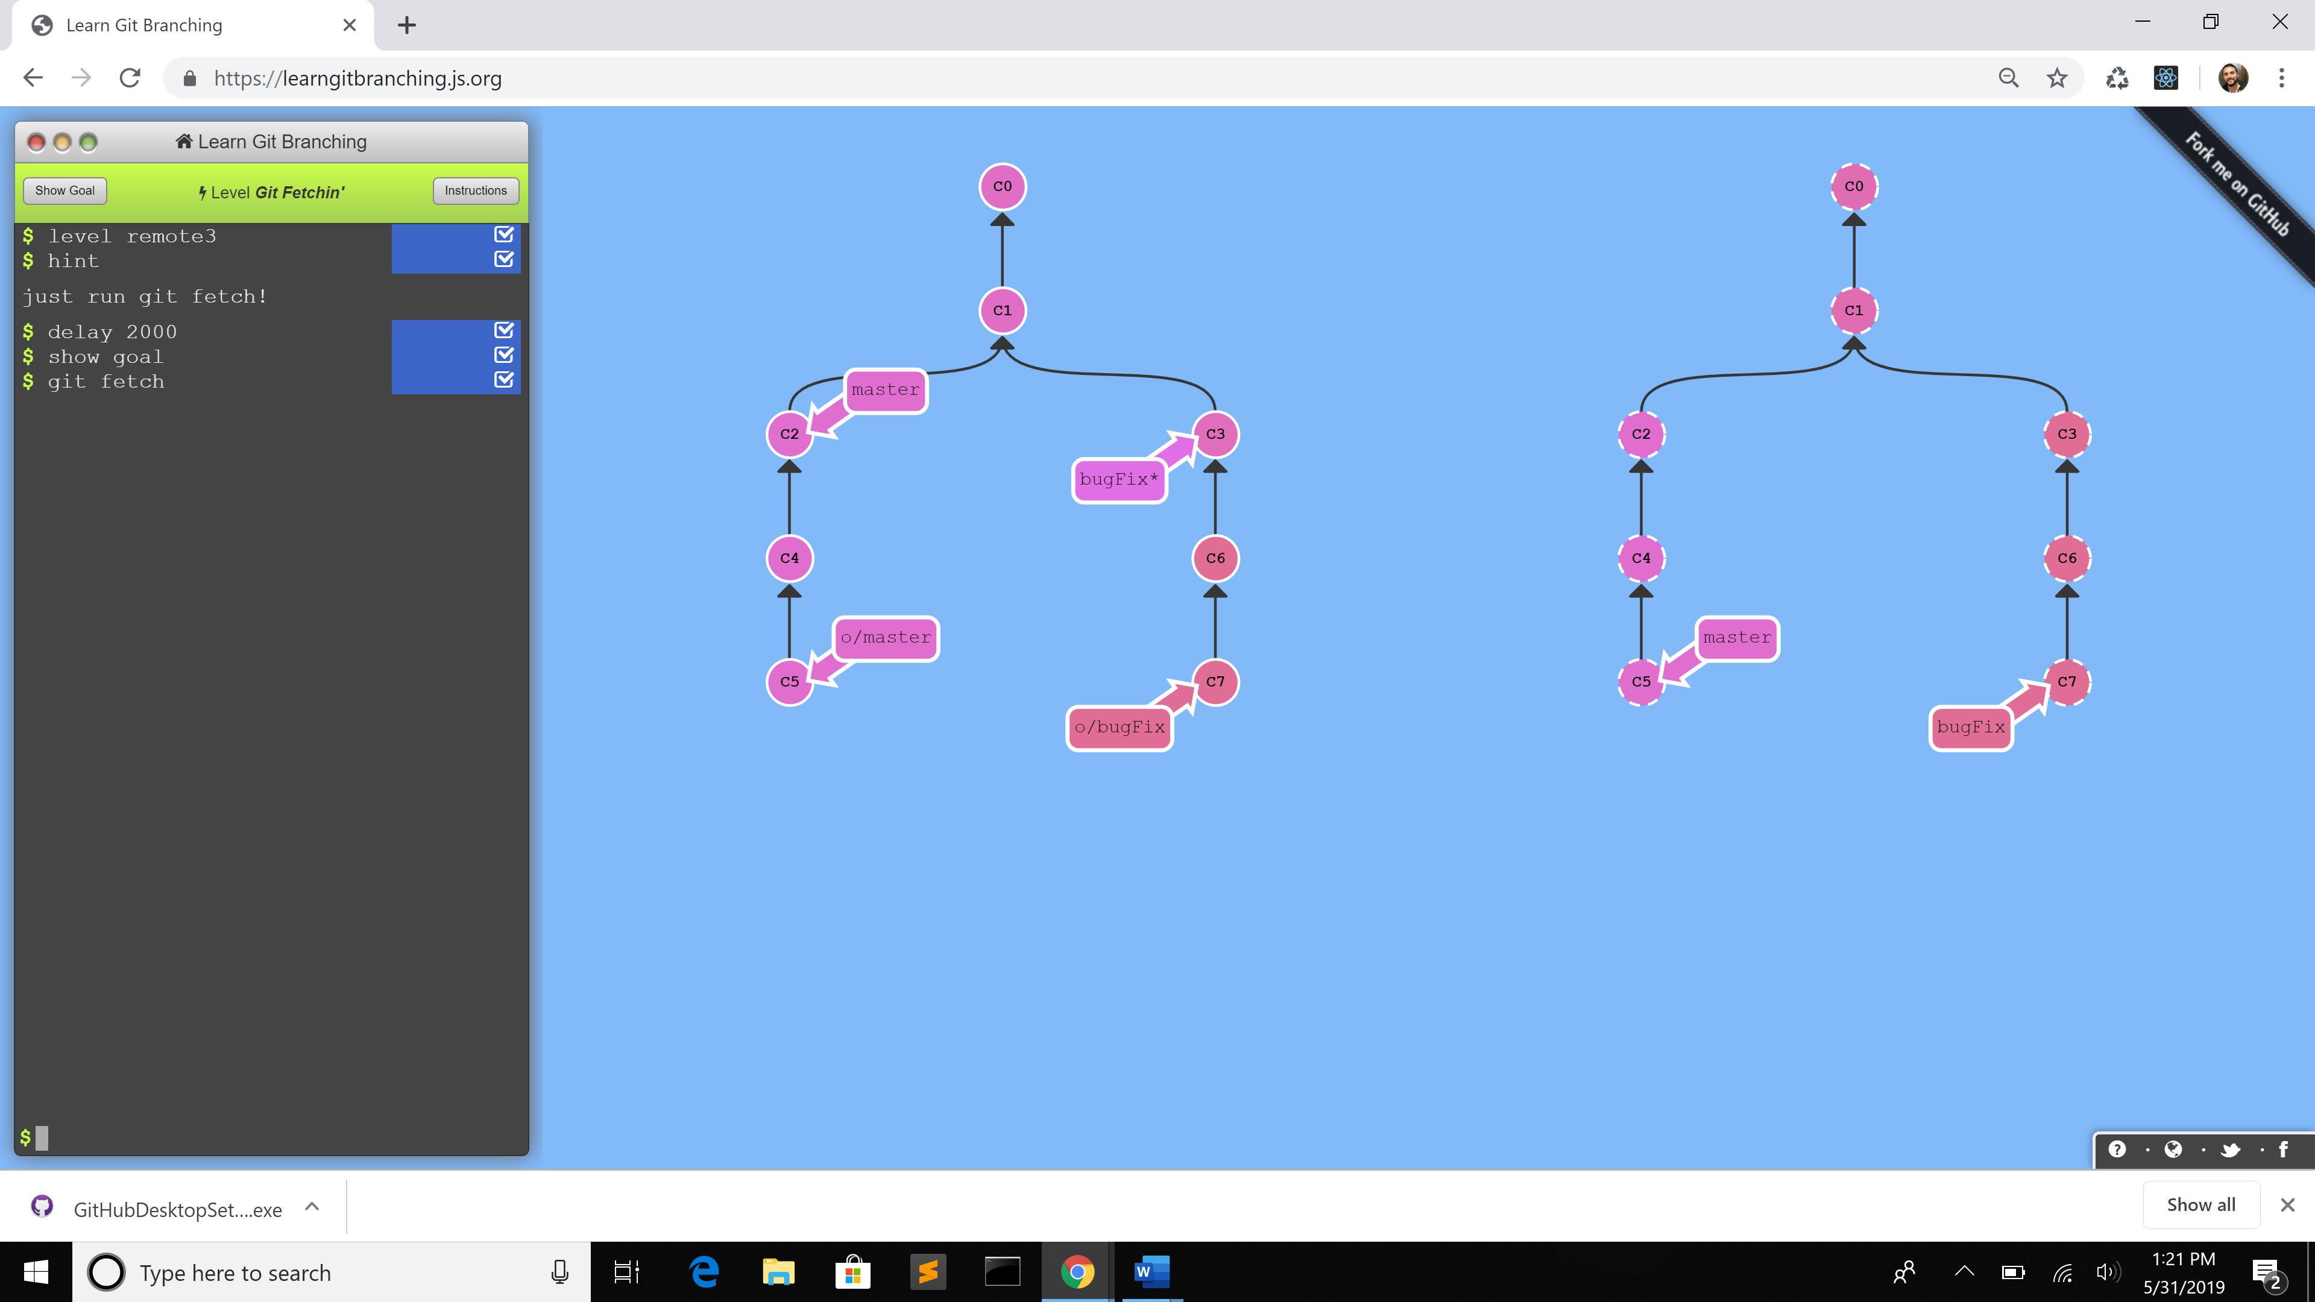

1. Commands:
   1. git fetch - downloads the commits that the remote has but are missing from our local repository, and updates where our remote branches point

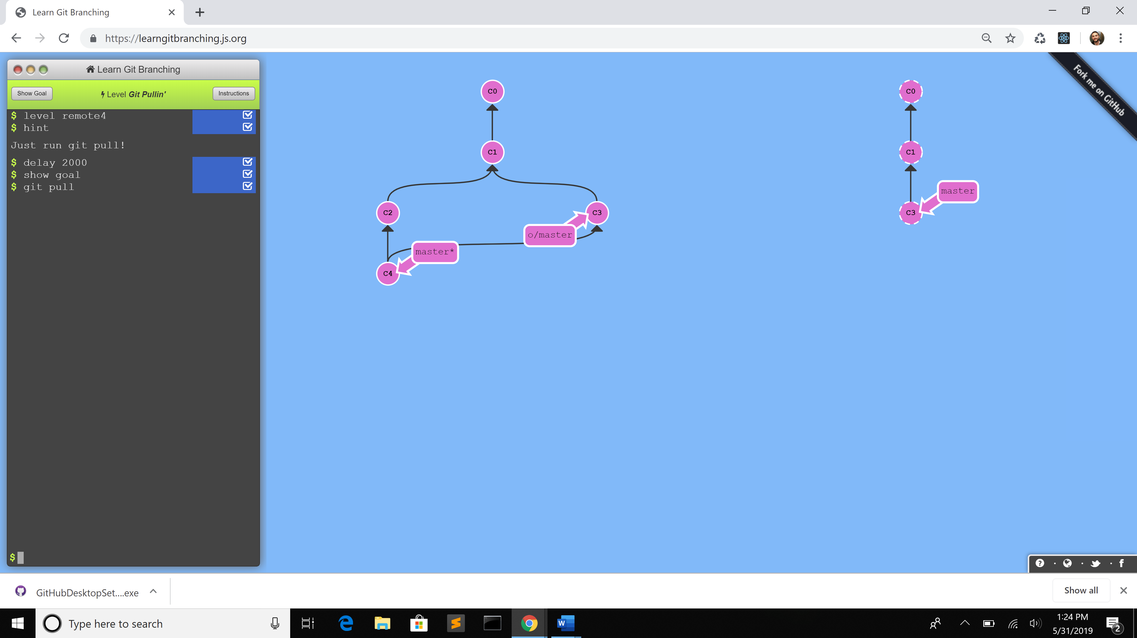

1. Commands:
   1. git pull - fetches remote changes and merges them

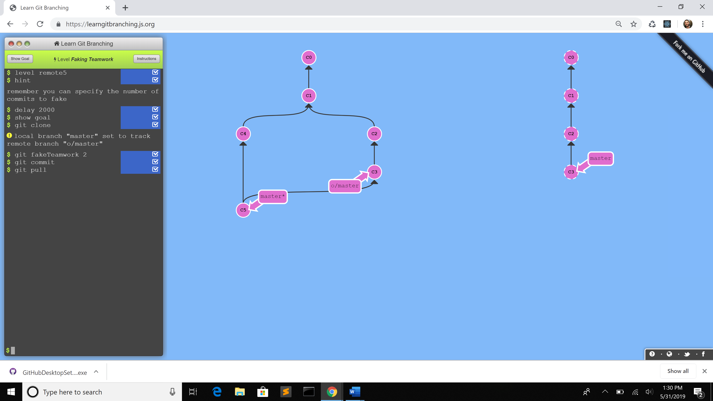

1. Commands:
   1. git clone
   2. git fakeTeamwork 2 - plop down a commit on master
   3. git commit
   4. git pull

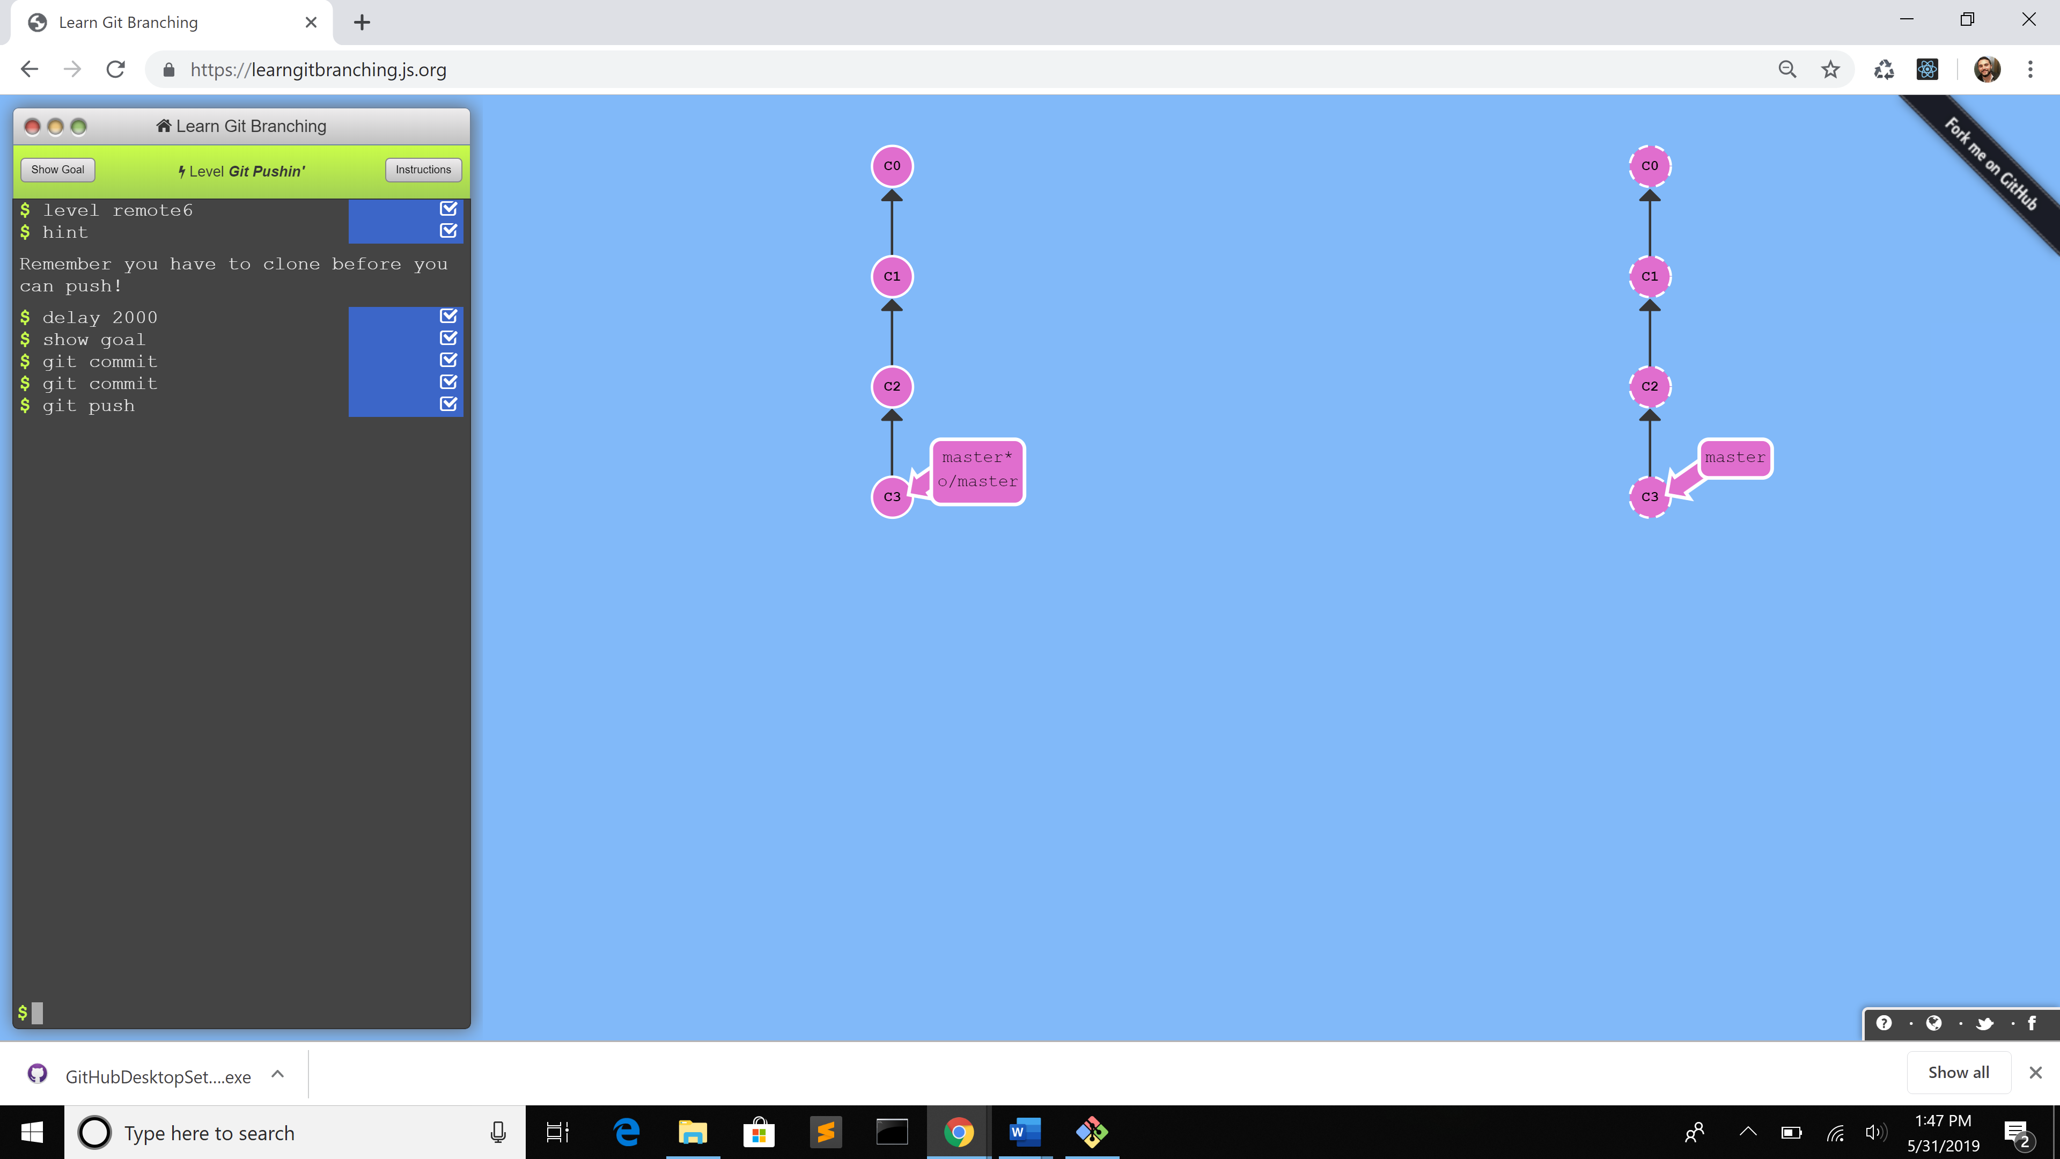

1. Commands:
   1. git commit
   2. git commit
   3. git push - publish new local commits on a remote server.

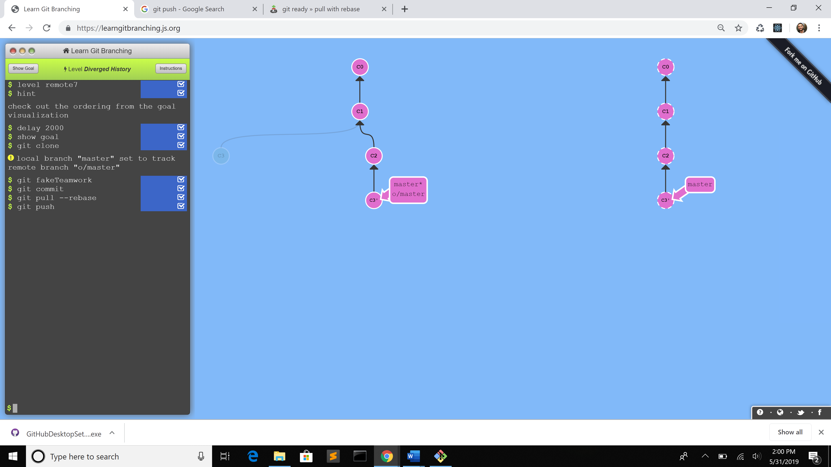

1. Commands:
   1. git clone
   2. git fakeTeamwork
   3. git commit
   4. git pull –rebase - does git fetch to pull data from the remote then calls git merge to join the changes received with your current branch’s work. However, that may not always be the best case. Use –rebase to rebase the changes in
   5. git push

**Part 5:**

* Repository - all files and directories of a particular project
* Commit - snapshots of file history
* Push - updates the remote repository which includes any local commits to a particular branch
* Branch - several lines of development that are pointers to a particular commit
* Fork - a copy of a repository where changes/updates can be made without affecting the original repository
* Merge - combines updates/changes from different branches
* Clone - creates a local copy of a project
* Pull - updates a particular branch in a local environment from changes committed from a remote branch
* Pull request - accept updates/changes from a fork to the original repository.

**Part 7:**

* Forked my own copy of from paceuniversity/courses to my own GitHub account.
* Ran command: **git clone** <https://github.com/JohnMads/courses.git> (to a directory on my local pc)
* Edited / updated the README file
* Ran command: **git add README.md**
* Ran command: **git commit -m "Added John Madias name and date"**
* Ran command: **git push -u origin master**
* Submitted a pull request with my changes to the master pace university repo